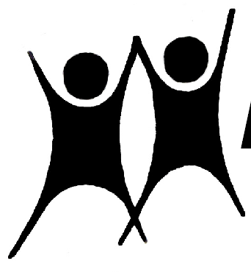

NAPE

Spring 2023

News, Events and Contacts
NAPE National Office
PO Box 1679,
Northampton,
NN2 1JW

NEWS
Telephone: 07734 772521
Email: nationaloffice@nape.org.uk
Website: https://nape.org.uk/

Officers: Chair: Mike Aylen: MikeAylen@aol.com
Vice Chair: Mark Taylor: taylormc@mac.com
General Secretary: Robert Young: rmyoung1942@yahoo.co.uk
Treasurer: Angelo Pinto: angpinto@gmail.com
Information Officer: Peter Cansell: petercansell@gmail.com
Podcast: https://www.educationonfire.com/national-association-for-primary-education

Welcome to this Spring edition of NAPE News.
I hope you enjoyed the Easter break and have returned refreshed.

The business of NAPE continues apace and we still facilitate the Primary Umbrella Group (PUG), with a recent Q & A with Stephen Morgan, the shadow minister for education, being very useful for attendees from a wide range of subject and other associations.

We attend the All Party Parliamentary Group (APPG) for the teaching profession which continues to meet, despite the massive upheavals in government, with a recent discussion on the important topic of accountability and inspection of great value in the current climate.
The National Executive met online in March, with much discussion around The Primary Education Summit.
I'm pleased to say that, to start off the summit, the Annual Schiller Lecture took place at Bannockburn Primary School, Greenwich, despite rail and teacher strikes, on March 15^{h}, with an excellent presentation by Neil Hawkes. There was a healthy audience for the live event and many more participants online the lecture is available here. I strongly recommend that you take some time to watch it as Neil delivered a message which has significance for everyone in school and linked the ideas of Christian Schiller very strongly to the values based education Neil talks about.
This followed up on our association with the Oxford School of Thought last year where Dr Hawkes held a very valuable session called The Inner Curriculum with strong links to his worldwide work on Values Based Education. This is also available online here.
The Primary Education Summit was a monumental effort from the team at NAPE to produce a 2 week extravaganza of high quality discussions, informative presentations and valuable resources. You might not have been able to attend every event at the time but all 20 are available on catch up here.
Our Podcast is growing considerably in its global reach and continues to attract high quality interviewees, with Pete Higgin, Joint CEO of Punchdrunk Enrichment ( a charity who create transformative immersive experiences for education, community and family audiences) due to make an appearance very soon. This is timely as they are the current subject of Radio 4's charity appeal presented by children’s author Michael Rosen on BBC Radio 4, the BBC Sounds app, or online from the 23rd-29th April.
We continue to have links with the Helen Hamlyn Centre for Pedagogy and were very pleased to welcome one of its directors, Professor Dominic Wyse, as a contributor to our summit discussion on Primary Assessment.
The ICAPE report, which Dominic wrote with Professor Alison Bradbury, is also available on our website.
Some ways to make the days more interesting for children are offered by Punchdrunk Enrichment, as described above, but also news of the Celebration Day Writing Competition for 2023, judged by children’s author Emma Chichester Clarke.
This writing competition asks children to retell the story of someone courageous from history that we can be inspired by today in support of the upcoming national day of remembrance, Celebration Day, on 28th May.
I'm also pleased to pass on news of a free resource from Sammhe who are offering a free air quality monitor for schools to help pupils and staff learn about the quality of the air in their classrooms.
We continue to campaign with More than a Score to push against the narrowing curriculum and you can see the good advice from children regarding the forthcoming SATs here.
With a little more advice here
